# DOMAIN PROJECT-1

## SYNOPSIS

**ON**

## Topic Name: Pathfinder AI

|  |  |  |  |
| --- | --- | --- | --- |
| **Submitted By** | | | |
| Keertivallabh Sharma | Jyotiraditya Singh | Shrey Sharma | Rishav Singh |
| R2142220539 | R2142220530 | R2142220169 | R2142220149 |

***Under the guidance of***

## Dr. Panduranga Ravi Teja

Professor



# School of Computer Science

**UNIVERSITY OF PETROLEUM AND ENERGY STUDIES**

**Dehradun-248007 Aug-Nov, 2024**

|  |  |  |
| --- | --- | --- |
|  | **Index** |  |
| **Contents** |  | **Page Number** |
| **Chapter 1: Abstract** |  | 3 |
| **Chapter 2: Introduction** |  | 3 |
| **Chapter 3: Problem Statement** |  | 6 |
| **Chapter 4: Literature** |  | 8 |
| **Chapter 5: Objectives** |  | 8 |
| **Chapter 6: Methodology** |  | 10 |
| **Chapter 7: System Requirement** |  | 10 |
| **Chapter 8: PERT Chart** |  | 10 |
| **Chapter 9: References** |  | 10 |

# Chapter 1: Abstract

The rapid growth of urban areas and the increasing need for efficient transportation solutions demand innovative approaches for navigation applications. This requires advanced tools and techniques. Our project aims to develop a prototype application that employs a combination of pathfinding algorithms to determine the optimal route for navigating between selected locations. The proposed solution will allow users to interactively upload city-wide maps, select specific destinations, and mark key points such as hospitals, offices, government buildings, airports, and stations. The application will compute the most efficient route based on factors like the priority of important locations. Our prototype will be an effective navigation tool by integrating an intuitive user interface with advanced algorithmic processing. This approach optimizes route selection and considers the socioeconomic and infrastructural importance of the connected locations, leading to a more balanced and efficient navigation experience. Through this project, we aim to demonstrate the feasibility and practicality of algorithm-driven decision-making in navigation applications, providing a valuable contribution to enhancing user navigation experiences.

Keywords: Path-finding algorithms, Djikstra’s algorithm, A* algorithm, Route planning,

# Chapter 2: Introduction

Efficient route planning is crucial for improving navigation, particularly in a rapidly developing country like India. Traditional methods often fall short in integrating multiple dynamic factors, such as traffic density, route feasibility and the strategic importance of key locations. This project aims to address these challenges by developing a prototype application that utilizes a modified version of pathfinding algorithms for optimizing navigation routes. The application allows users to upload city-wide maps, select destinations, and mark vital locations such as hospitals, government buildings, and airports. It then provides an optimal route, connecting the selected locations via major landmarks.

# Chapter 3: Problem Statement

* **Challenges in Navigation Application Development:** India faces significant challenges in developing navigation applications due to its vast geography, diverse terrains, and rapidly growing urban and rural populations.
* **Inadequate Consideration of Critical Factors:** Current navigation applications in India often fail to adequately consider multiple critical factors, such as high traffic density in urban areas, varied terrain conditions (mountains, plains, deserts), and the strategic importance of locations like hospitals, offices, government buildings, airports, and railway stations.
* **Suboptimal Navigation Decisions:** Inefficient navigation tools can lead to suboptimal route choices that do not effectively connect major destinations or serve essential public services, resulting in increased travel times, higher costs, and limited access to critical services for many communities.
* **Need for an Advanced Navigation Tool:** India lacks an interactive, data-driven tool that allows users to dynamically select destinations, mark important locations, and optimize routes based on various parameters, considering both economic and social impacts.
* **Objective of the Project:** To develop a prototype navigation application tailored for India's needs, utilizing a modified version of Dijkstra's algorithm. The tool will enable users to upload city-wide maps, select destinations, and mark key locations, thereby computing the optimal route for navigation. This approach aims to enhance decision-making for route planning, ensuring efficient, cost-effective, and strategically sound navigation experiences across India.

# Chapter 4: Literature

Efficient design and planning for navigation have long been studied in the context of route optimization. Various algorithms and models, such as Dijkstra’s algorithm, A* search, and genetic algorithms, have been employed to enhance route efficiency, reduce travel time, and minimize costs. Dijkstra's algorithm, introduced in 1959, is a widely used method for finding the shortest path between nodes in a graph and is commonly applied in navigation problems. However, its traditional form does not account for multiple dynamic factors, such as traffic density, route feasibility, or the priority of essential locations, which are crucial in real-world scenarios.

Research on route optimization in diverse contexts highlights the importance of considering multiple criteria beyond mere distance. Studies suggest that incorporating factors such as population density, location accessibility, economic benefits, and environmental impact can lead to more effective and user-friendly navigation solutions. Multi-criteria decision-making (MCDM) models and Geographic Information Systems (GIS) have increasingly been utilized to improve the accuracy and relevance of navigation planning in various geographic and socio-economic contexts.

In recent years, there has been growing interest in integrating GIS with optimization algorithms to enhance navigation applications. GIS provides a powerful platform for handling large spatial datasets and visualizing complex geographic information, while algorithms like Dijkstra’s can perform efficient computations on these datasets. Previous works have demonstrated that combining GIS with optimization techniques allows for more interactive, data-driven navigation processes that consider multiple constraints and objectives.

This project builds on the existing literature by developing a prototype navigation application that integrates modified pathfinding algorithms with GIS-based tools. Unlike traditional approaches, our application allows users to interactively upload maps, select destinations, and mark critical locations, considering diverse criteria such as traffic density, route feasibility, and strategic importance. This approach aligns with the needs of diverse regions, where varied geographic, demographic, and economic conditions require adaptable and context-sensitive navigation tools. By leveraging the strengths of both classic algorithms and modern GIS technology, this project aims to contribute to more efficient, user-friendly, and data-driven navigation solutions.

# Chapter 6: Methodology

The project begins with data collection, where city-wide maps are obtained from various sources. In the data preprocessing phase, these maps are cleaned and converted into a compatible format for the application. Next, UI development focuses on creating an interactive user interface for easy user interaction. Following this, the algorithm implementation phase involves applying modified pathfinding algorithms like Dijkstra's, A*, etc., to determine optimal routes for navigation. The application is then enhanced through integration with mapping libraries to visualize the maps and routes effectively. Finally, the project undergoes iteration and deployment, where it is tested, refined based on feedback, and deployed for use.

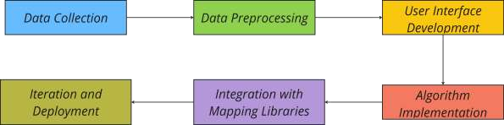

# Chapter 7: System Requirement

## Software Requirements

Operating System : Windows 10/8/7 (32-bit or 64-bit)/ Linux Software : Text Editor, Browser

Compiler : GCC, Python

## Hardware Requirements

Processor : Dual Core 2.7 GHz or better

RAM : 512 MB or higher

Disk Space : 512 MB

# Chapter 8: PERT Chart

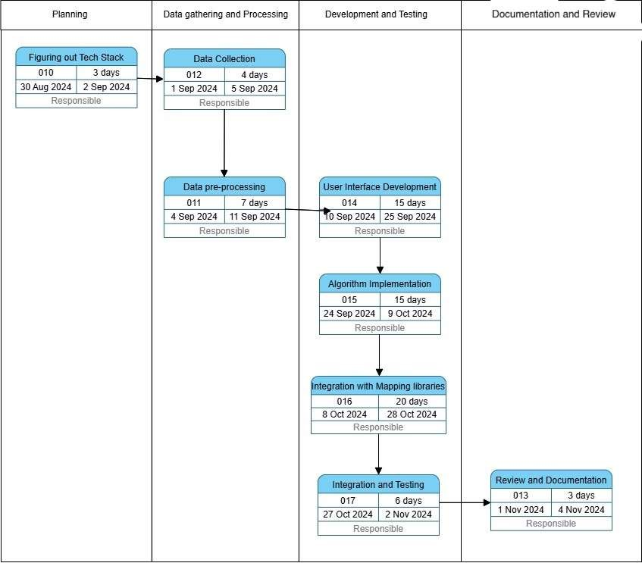

**Chapter 9: References**

* + <https://docs.mapbox.com/help/glossary/mapbox-js/>
  + [Google Maps Platform. (n.d.). Google Maps API Documentation](https://mapsplatform.google.com/india/?utm_source=google&utm_medium=cpc&utm_campaign=google_maps_non_brand_india&gad_source=1&gclid=CjwKCAjwreW2BhBhEiwAavLwfBNDlxkvCX_lpP7-VYcH_TyD8Jumj26N8fO4x3MWLkUL_WY4k_7RDxoChHUQAvD_BwE&gclsrc=aw.ds).
  + [Project Management Institute. (2017). A Guide to the Project Management Body of Knowledge](https://www.pmi.org/pmbok-guide-standards/foundational/pmbok) [(PMBOK Guide) (6th ed.).](https://www.pmi.org/pmbok-guide-standards/foundational/pmbok)
  + <https://www.youtube.com/watch?v=J7eyI1ClDOA>
  + [https://www.iirs.gov.in/iirs/sites/default/files/pdf/2023/Overview_of_Remote_Sensing_and_GIS](https://www.iirs.gov.in/iirs/sites/default/files/pdf/2023/Overview_of_Remote_Sensing_and_GIS_Applications_E-Book.pdf)

[_Applications_E-Book.pdf](https://www.iirs.gov.in/iirs/sites/default/files/pdf/2023/Overview_of_Remote_Sensing_and_GIS_Applications_E-Book.pdf)

* + <https://www.sciencedirect.com/journal/isprs-journal-of-photogrammetry-and-remote-sensing>